# CS 470 Module Five Assignment One Guide

## Part One: Creating the Question Table

1. Navigate to the DynamoDB console page. As in the previous modules, navigate to the console through the **Services** drop-down menu and select the service you want. In this case, select **DynamoDB**. You can find DynamoDB under the **Database** group, or you can type it in the search bar.

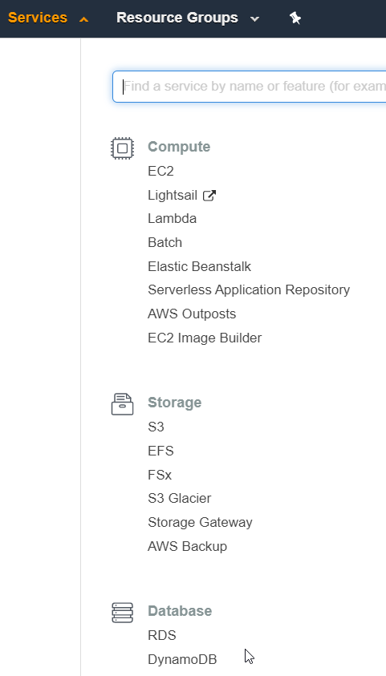

1. Select the **Create table** button.

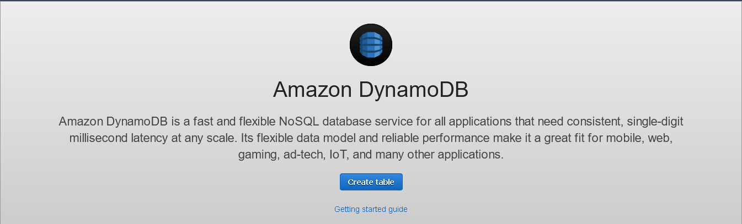

1. Enter “Question” in the **Table name** field and “id” in the **Partition key** field. Set the **type** as “String.” Make certain that the **Sort key** box is empty. Click the **Create** button in the lower-right corner.
2. AWS will create the table. Creating the table may take a minute or two. When it is complete, you will see the table selected and the table details view.

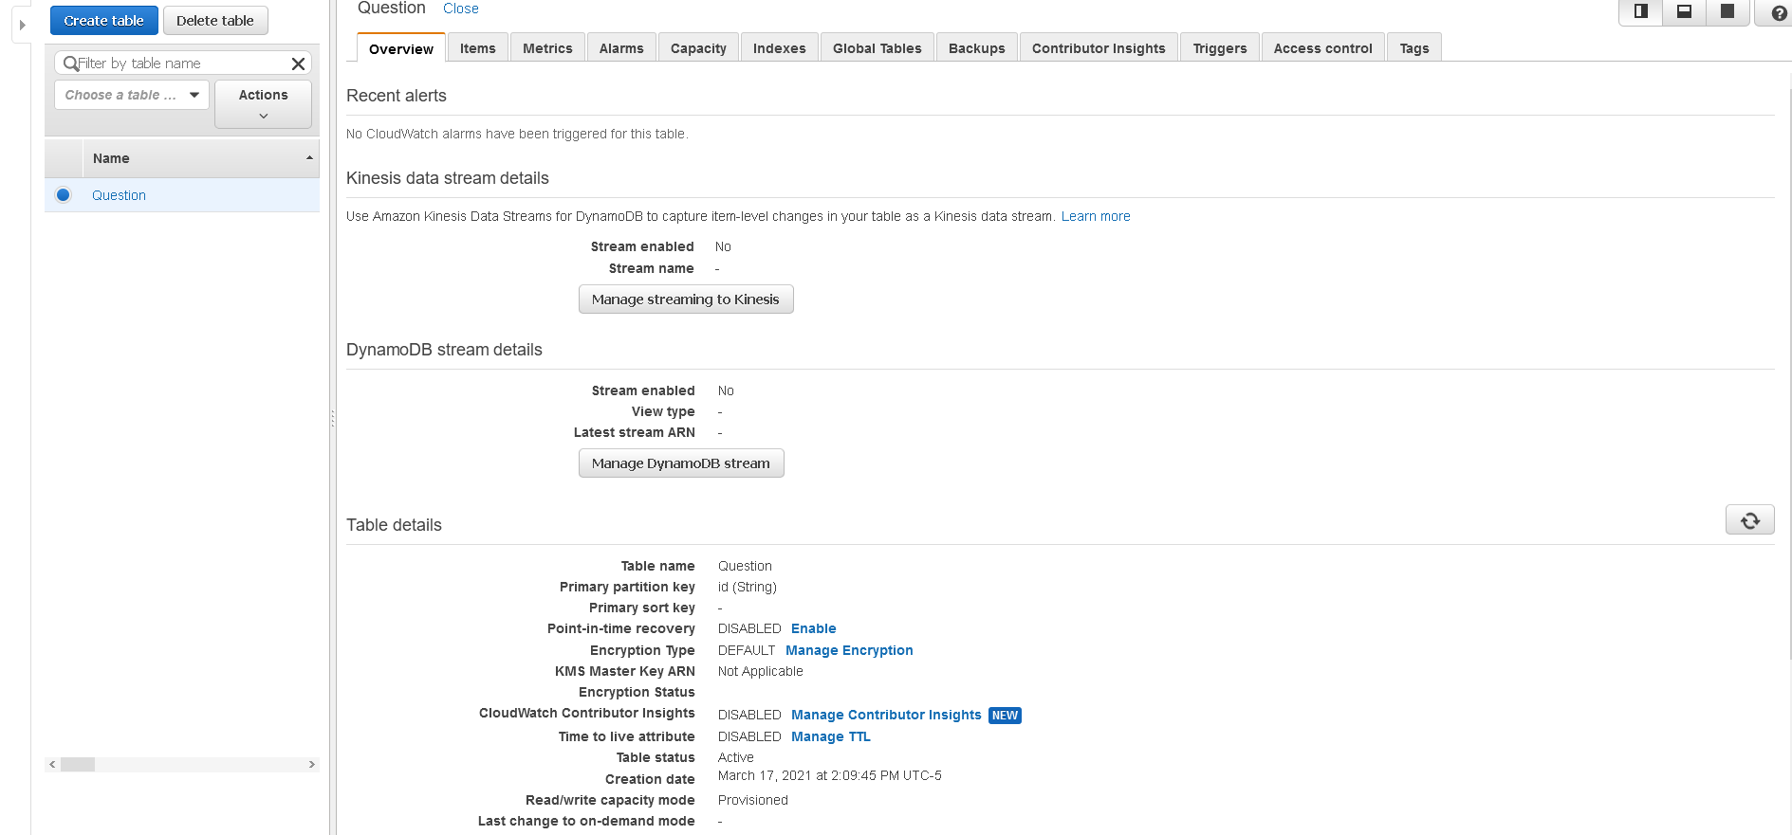

Congratulations! You have created your first DynamoDB table.

Before moving to Part Two, click the orange **Explore table** **Items** button. The console will scan the table and show you all the records. You have none. It also shows you all your attributes. In this case, you only have one, the partition key “id”. This page will be helpful to you for the rest of this module and the subsequent modules. This page allows you to see the items in your database quickly.

## Part Two: Adding Items and Attributes

1. Since DynamoDB is technically schema-less, it creates a schema based on the items you insert. As such, you will not add attributes in the traditional way before you insert data. You will add attributes by inserting an item.
2. Picking up from step 6 in Part One, click the **Create Item** button at the bottom of the page. The console will show the **Create Item** screen. Here, you enter items directly.
3. Click the **JSON view** button in the top right. This view will allow you to enter items in JSON format instead of attribute by attribute in the tree view.
4. Paste the JSON below into the window, overwriting the existing text. A new GUID has been generated as the id to ensure uniqueness.

{

"id": "5eb59b7f80433e00045a7dfb",

"categorySlug": "angular",

"questionSlug": "what-is-angular",

"question": "What is Angular",

"negativeVotes": 0,

"positiveVotes": 0,

"answers": []

}

**Note:** If you receive a format error, make certain that **View DynamoDB JSON** is turned off at the top.

1. Click the **Create Item** button in the lower-right corner.
2. You should now be able to see the item in the **Items Returned** section at the bottom of the page.

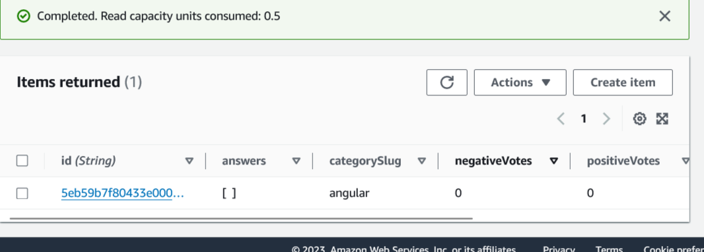

1. As you can see, DynamoDB created the other attributes and populated the item.
2. Select the id link in the **id** field. Selecting the link will bring up the **Edit Item** screen.

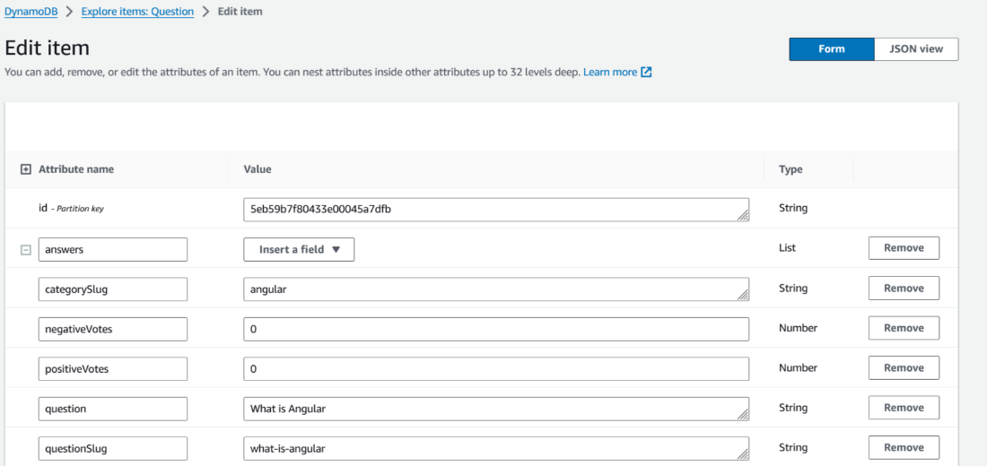

1. From this screen, you can update your record if necessary. Click **Cancel** to exit the editing view.
2. There is one last thing to know about this screen. Select the **Actions** drop-down menu next to the **Create Item** button while your item is selected. This menu allows you to duplicate, edit, or delete an item or export the table to a CSV file. If you duplicate the item, you must provide a new id value. If you delete the item, you will be asked to confirm before deleting it. **Export to .csv** allows you to export your database.

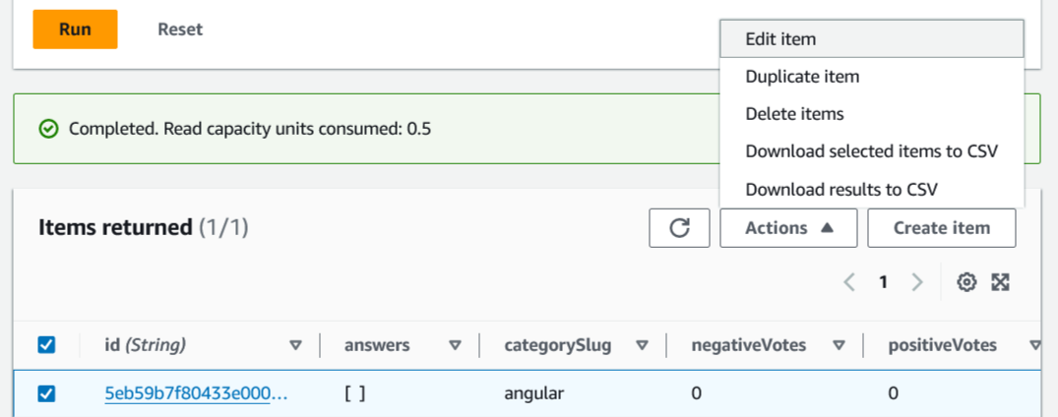

1. Modify the JSON above to create four more Question entries. Make certain each id is unique.

Congratulations! You have created and populated your Question table. You will create the Answer table in Part Three. You could have designed Answer as an array of answer items inside your Question table, but the Angular application expects Answer to act as an independent table.

## Part Three: Creating the Answer Table

1. Using the steps for the Question table, create an Answer table with an **id** partition key and **string** type.
2. Select the **Items** tab for the Answer table and create an item using the JSON data below. Make certain the **questionId** matches the id used for an item in your Question table.

{

"answer": "Because it is the backbone of angular",

"negativeVotes": 0,

"positiveVotes": 0,

"id": "5b8629d2af53c20004793ac0",

"questionId": "5eb59b7f80433e00045a7dfb"

}

That’s it! You now have your tables and can work with your data through the AWS console.